Res Nova
Insurance survey
Dated 15 th September 2009

With further valauation on the 25th October after renovation.

LIST OF CONTENTS.

This Report contains the following Parts:-
Summary and opinion of value

Recommendations and Suggestions Conclusion
The Survey.
The Hull and Fittings.
Ultrasonic results.
The Machinery and Transmission.
The Domestic Systems.
The Safety Items.
.
Miscellaneous Items

Annex 1. RCD and MCA Sea Areas
Annex 2. General Information

Goos and Klaas Kramer
Zaandam
Holland

15 th September 2009

Dear Sirs

This is to confirm that, at your request, in accordance with our Standard Contract of Employment and Codes of Practice including those laid down by the International Institute of Marine Surveying the undersigned attended the:-
Res Nova
Ashore in Zaanstad and there effected, without the vessel being fully opened up for survey, a hull survey for insurance purposes.

Summary

In our opinion Res Nova was found at the time of the survey in good structural and mechanical seaworthy condition, an insurable risk under the Institute of London Underwriters Yacht Clauses for use within the sea areas laid down by European Directive (94/25/EC) dated 16th June, 1994 Cat C max force 4 in smooth sea conditions provided that all RECOMMENDATIONS as given below are carried out within the stated time limits.
.
In light of all the works done to Res Nova and all the recommendations completed.

LIST OF RECOMMENDATIONS AND SUGGESTIONS.

RECOMMENDATION 1 The gas and shore power systems are condemned and should be bought up to current Boat Safety standards and a BSS certificate issued.Fuel lines and exhaust systems to be bought up to BSS also.

See www.boatsafetyscheme.com
Before use of either.

RECOMMENDATION 2 We would recommend that a new automatic 12 v bilge pump with alarm is fitted in the Saloon bilge and a non automatic one in the engine bilge with an oil filter in the diascharge line to BSS and a bilge alarm is fitted in the main saloon and engine bilge.

As soon as possible after launching

RECOMMENDATION 3 We would reccommend that access is made to the bilge in all accommodation spaces
As soon as possible after launching

The above have all been completed

We value her as follows:

Opinion of Value.

This is to confirm that it is our considered opinion that, on an 'as is - where is' basis, if placed and kept in sound and seaworthy condition, charter free and free of registered encumbrances and maritime liens and any charges, taxes, mortgages and other debts whatsoever, given a willing buyer and seller on the usual sale agreement, the vessel has a current open market value in the region of £95,000.00 excluding VAT.

(NINETY FIVE THOUSAND POUNDS STERLING.)

This letter is given in good faith as a statement of opinion on the facts available to us from the usual sources at the time of our survey and is based on known average retail sales achieved by vessels of similar type and size in the United Kingdom but any person wishing to rely on this letter should make their own enquiries as to the validity of those facts and sources. The value given above should not be confused with the replacement value, which may be considerably higher, particularly in the case of rare or unusual vessels. Forced sale value would be lower.

Yours faithfully,

Colin Mallard South
Dip. Mar. Sur. M.I.I.M.S. R.M.S.

Survey

Type of Vessel.

Dutch Luxe motor of steel construction part riveted and part welded where overplated with a Daf 575 fresh water cooled 105 hp Diesel engine shaft driven. Internal framing in good condition and is of adequate scantlings for vessel of this size.

Principle dimensions given by owner :
Length 15.0 m
Breadth 3.0m
Max draught 1.0 m
Displacement Approx 20 mt

This Report should not be taken to imply that the vessel has sufficient freeboard or reserve buoyancy or that the vessel is in any way suitable for its proposed use.

Registration.
None

Builders and Date of Build.

Dutch built in 1900.

General Statement on the Condition of the Survey.

The vessel was found in commission as a live-aboard.
Access to the hull was limited by the blocks .
The Reason for the Survey.

The reason for the survey was to carry out a hull survey for insurance purposes.
We have not inspected woodwork, metalwork or other parts of the vessel which were unexposed or inaccessible. No dismantling of the structure other than the removal of such normally portable or readily accessible hatches was undertaken. Spaces where access was clearly restricted are noted within the Report.
This Report should not be taken, therefore, to guarantee the existence of defects, isolated damage or deterioration concealed by such ceilings, linings, cabin soles or floors, paints, fillers etc.

External Hull Examination.
The above waterline areas were found in good condition with minimal pitting and paint coatings are in good condition. The turn of the bilge and to the waterline port and starboard has some minor pitting –under .5 mm but with a small number of larger pitts .75mm - numbering 10 to port and 8 to starboard as these were over a small area it was felt prudent to fill the larger pits with epoxy filler.
Three areas over overplating were agreed with the yard on port side aft and forward and a small patch amidships again on the port side.These were overplated in 5 mm.

Deck and superstructure.
All in good condition . Forward windlass in good condition. Some superficial rusting to aft accommodation shell-minor.Abrade treat with Vactan or similar and re-paint.

Microbiological Attack.
No signs.

Ultrasonic Thickness Measurements.
The vessel was then subjected, where practical, to an ultrasonic thickness examination in accordance with the Code of Practice published by the International Institute for Marine Surveying.
Selected points over the sides, along the wind and water strake and under the bottom in areas where the maximum corrosion may be expected and such as were reasonably accessible These were then cleaned of surface coatings but not any epoxy filler and scale and the thickness measured ultrasonically using A Cygnus thro paint meter ultrasonic thickness gauge.
The machine used had a manufacturer's stated calibrated accuracy of ± 0.1 mm which was independently checked at the time of the survey on a section of the ship for which the thickness could be physically measured by vernier gauge to ensure that it was reading correctly
It should be noted that certain areas of the shell could not be tested by this means due to inaccessibility for the probe, for example where the hull was sitting on the grid. Over the rest of the shell, a ring of readings were taken round the hull at positions approximately one metre apart. The individual readings are given in the tables below.

The readings are given in mm.

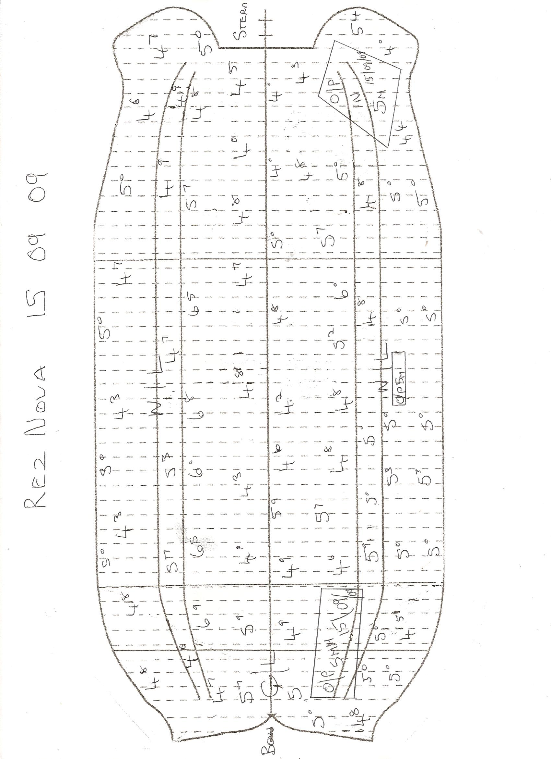

Anodes.
6 new fresh water anodes were fitted and these should give up to 5 years protection in normal conditions.
Stern gear.
All in good condition. Stern gland, 3 bladed bronze propeller and stainless steel shaft.

Skin Fittings and Seacocks.
Dutch toilet. Engine raw water inlet-new. The rest of the skin fittings are above water.

Machinery. Not part of the survey

The vessel was powered by Daf 575 fresh water cooled diesel engine of approx 110 hp. The engine room is clean as are engine bilges and all systems are in good order and well maintained.The engine was run for an hours sea trial and stared from cold and runs well.
Steel fuel tank approx 65 litres system in good condition with adequate filtration.

Batteries. Wiring/Fuses.
All to be checked.
SEE RECCOMMENDATION
Fire Extinguishers.
Out of date. Fit 4 x 1 kg dry powder to BSS. Fit fire blanket.

Forward cabin.
All lined with berths sitting headroom and twin berths with hatches to deck and door to saloon .

Saloon
All lined with windows and dinette to port.

Galley

4 burner gas hob, sink with pumped water,gas refrigerator.

SEE RECCOMMENDATION

Wheelhouse

Wheelhouse with seating area and steering position to port and also upper steering position with hydraulic lever steering. Working. Can be converted back to wheel steering.

Toilet compartment
Dutch toilet. Sitting headroom.

Aft double cabin.
Sitting headroom but cabin roof could be raised and there is a void under the floor of some 200 mm to give standing headroom .

Aft deck.

Engine room
Under wheelhouse.All in good clean condition with access from wheelhouse floor.

Water systems
Pumped system with steel water tank approx 200 litres.

Windows.
In fair condition.

Rudder and Hangings.
The steel rudder was of the post hung single barn door type in good condition. Hangings in good condition. Concrete around the rudder post but no sign of any leaking.
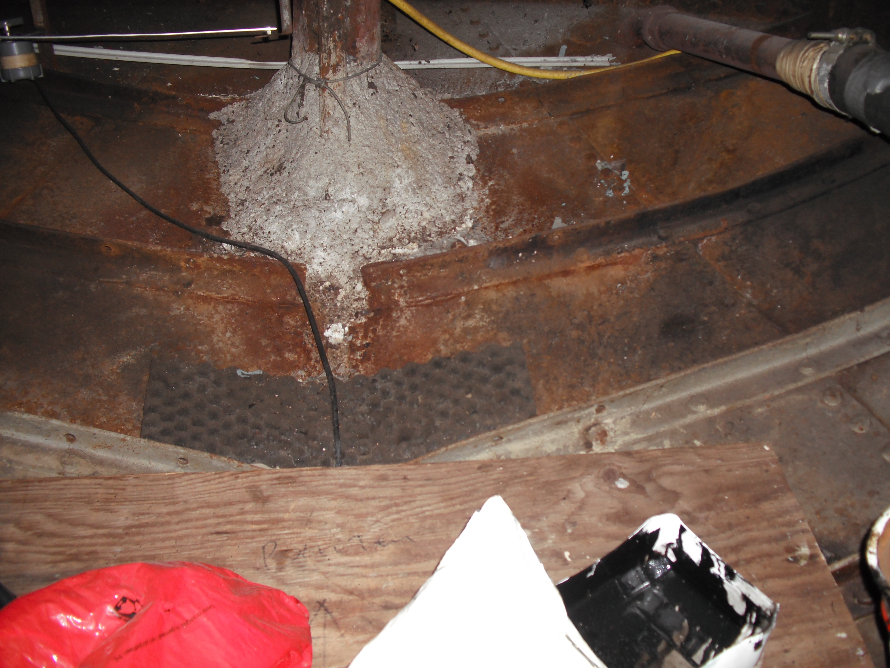
Navigation equipment
None

Safety equipment
Horseshoe lifebuoy.

Ground Tackle
Adequate for inland waterways cruising
Together with the deck fittings the arrangements were such that they could be considered to be a strong point in accordance with the EU Recreational Craft Directive. The warps were examined and found sufficient in number and in good condition.

Bilge Pumps.
None.
SEE RECCOMMENDATION

Thickness survey

An essential part of the General Condition Survey of this type of vessel is the determination of the remaining thickness of metal in various critical areas of the main structure and this is almost invariably carried out using ultrasonic methods. The confidence limits that may be placed on the measurements is a direct function of the techniques involved, the skill and training of the operator and the type of machine used. The accuracy levels are of particular importance for future surveys of the hull structure whereby rates of corrosion may be determined. The instrument used in this survey, however, was of the digital read out multiple pulse single echo type which has the disadvantage in that it cannot discriminate between echoes from the back wall of the item being measured or flaws in the interior of the plate and the Surveyor has no means of checking for such flaws.
This fact must be borne in mind when interpreting the readings given in this Report. Similarly on heavily corroded plates the slope of the echo can be poorly defined leading to errors that cannot be quantified. Laboratory tests have shown that the achievable accuracy varied between ± 0.5 mm on samples with a soft coating on the opposite wall and ± 3 mm where the sample had hard haematite or magnatite rust scale on the opposite wall.
Further, while every effort was made to place the probe squarely onto the ground surface, in the normal circumstances of shipyard work, this cannot be guaranteed and this may be a further source of error. Nevertheless it can be shown, statistically, that there is a 95 % probability that the true thickness lies within ± 0.5 mm of the readings given in this Report.

The minimum allowable thicknesses given above are all computed from formulae determined from and based on standard naval architecture 'Strength of Ships' theory.
In assessing the above thickness measurements the following qualifications must be observed:-

- The thickness readings given in each case are in mm and it is emphasised that the readings shown give no guarantee that the same thicknesses apply to other parts of the shell, bulkhead or other plating or structural items where these items were not measured at this time. The noted thicknesses must not be interpolated between adjacent thicknesses however closely spaced nor the mean figures given above regarded as the ‘average’ thickness for the plating or internal structure to which they apply.

- The number of thickness measurements taken on the shell was calculated on a statistically significant percentage of the area of the structural item under test and the readings were distributed in accordance with standard marine surveying practice but no guarantee can given that all thin areas on the shell plating have been found at this time.

- Where practical and appropriate these measurements were taken at the bottom of any local pitting.

- The measurements are point measurements only not area measurements but are the arithmetic mean of a reasonable number of measured thicknesses taken at that point.

- In judging these measurements it should be taken into account that they are ultrasonic measurements only and that they were taken only on those spots upon which doubt arose after close up visual inspection and hammer testing of all the structure.

- It should be noted that thickness measurements however closely spaced do not guarantee that the steel surface on the opposite side i.e. on the inside of the vessel is free of corrosion, pitting or other defects.

- It is relevant to note that the Classification Societies allow a diminution of thickness on the shell plating and other primary structure of not more than 15% but on secondary structure of up to 20% is acceptable before requiring that such a corroded item be renewed. Tertiary structure may be allowed to deteriorate by up to 50% of the original thickness.

- Where the actual thicknesses, as measured, of bottom or side shell plating fall below the allowable minimum, the metal structure in way requires remedial treatment within the time limits laid down in the RECOMMENDATIONS given hereunder. In this respect, we do not, in general, recommend that thin areas of such bottom or side plating be fitted with doubling plates that exceed two frame spaces in length and/or 750 mm in width as it is not possible to connect efficiently the middle of such large doubling plates to the existing plating and primary framing structure underneath. It is, in our opinion, better to crop out such thin areas back to metal of an acceptable thickness and renew the plate in way although it is accepted that this is more difficult and costly. Existing doubling plates, however, may be left in place. We do not recommend the use of slot welds in the attachment of such doubling plates.

- It should also be pointed out that the sample/population ratios given in the measurements given above must be considered to be fairly small and samples, however large and accurately taken, do not represent the population entirely and can sometimes be much in error.

- The thicknesses given are approximate only as the assumption is made that the standard speed of sound in 0.23 % carbon mild steel applied to this vessel. It was not possible to check that this assumption applied in this particular case and variations in material density, heat treatment and surface hardness all affect the actual value.

- The rolling margins of steel plate for shipbuilding and structural purposes are usually of the order of ± 0.2 mm and for bars ± 0.1 mm.

- The minimum thicknesses given above for the bottom/bilge and side shell include a corrosion allowance calculated as suitable for a five year dry docking period.
It was noted that some of the measured thicknesses were less than the recommended figures and these areas of the plating were specially examined and found in good condition and it was not considered necessary to fit doubling plates

(From the Official Journal of the European Union).

Category Definitions.

A. OCEAN: Vessels designed for extended voyages where conditions may exceed wind force 8 (Beaufort Scale) and significant wave heights of 4 metres and above may be experienced and vessels largely self sufficient.

B. OFFSHORE: Vessels designed for offshore voyages where conditions up to, and including, wind force 8 (Beaufort Scale) and significant wave heights up to, and including, 4 metres may be experienced.

C. INSHORE: Vessels designed for voyages in coastal waters, large bays, estuaries, lakes and rivers where conditions up to, and including, wind force 6 (Beaufort Scale) and significant wave heights up to, and including, 2 metres may be experienced.

D. SHELTERED WATERS: Vessels designed for voyages on small lakes, rivers and canals where conditions up to, and including, wind force 4 (Beaufort Scale) and significant wave heights up to, and including, 0.5 metres may be experienced.

ANNEX 2.

GENERAL INFORMATION.

Definitions.

In accordance with ISO 10088 (E):-

Readily accessible or normally portable means - capable of being reached for operation, inspection or maintenance without removal of any craft structure or use of any tools or removal of any item of portable equipment stowed in places intended for the storage of portable equipment such as lockers, drawers or shelves.

Accessible means - capable of being reached for inspection, removal or maintenance without removal of permanent craft structure. Hatch covers are not regarded as permanent craft structure in this sense even if tools such as spanners, wrenches or screwdrivers are needed to open them. Hatches for the inspection or maintenance of fuel tanks may be covered by uncut carpet, provided that all tank fittings can be inspected or maintained through other openings.

Opened up for survey means all lockers emptied, all portable hatches lifted or taken down, all loose ballast lifted and removed from the vessel, all bilges pumped dry and cleaned and the anchor cable flaked out on the hard stand or dock bottom.

In accordance with BS EN MA 101:-
Sanitation system means - a system comprising equipment designed for installation on board a vessel to receive, retain, treat or discharge sewage and equipment using any process to treat such sewage.

Sewage means - human body wastes and the wastes from toilets intended to receive or treat human body wastes.

In accordance with the RoSPA Handbook:-
Efficient in relation to a piece of structure, fitting, piece of equipment or material means that all reasonable and practicable measures have been taken to ensure that it is suitable for the purpose(s) for which it is intended to be used.

Watertight means capable of preventing the passage of water in any direction and, in accordance with ISO 11812 and 12216 . Weathertight means that, in any sea condition, water will not penetrate into the vessel.

Weathertight Openings are openings with a permanently available means of closure that:-

- Comply with the requirements of ISO 12216 for watertightness and
- When closed, still permit the safe continuous operation of the vessel, engine(s) and steering systems.

Appeared indicates that a close up examination or test of the particular system, component or item so described was not possible due to constraints placed upon the Surveyor (e.g. no power available, inability to remove panels, lack of cooling water or a specific requirement not to conduct destructive tests).

Serviceable or adequate means considered by the Surveyor at the time to be sufficient for a specific requirement or service.

Fit for intended use means fit for the stated use intended by the person instructing the survey.

The condition of items other than steel was assessed one the following scale:-

- Excellent condition means new or like new.
- Good condition means nearly new with only minor or cosmetic defects noted.
- Fair condition denotes that the item, component or system was found functional but will require minor repairs and will also require to be frequently monitored.
- Poor condition means that the item, component or system was found non functional and will require replacement or renewal within a specified time.

Definitions of Dimensions.

Length Overall (L_{OA}) is measured from the forward side of the stem to the aftermost point of the hull only and does not include stern/swim platforms, boarding ladders, pulpits, taffrails, rudders, bowsprits, bumpkins and similar extensions. If these latter are measured then a separate Length Extreme (L_{E}) is given.

Length on Waterline (L_{WL}) is measured from where the forward side of the stem cuts the waterline to the after point of the horn timber, sternpost or transom where this also cuts the waterline.

Beam or Breadth Overall (B_{OA}) is measured at the widest point of the hull and includes the thicknesses of wales, rubbing strakes and harpins and similar items.

Freeboard (f) is measured at the lowest point of sheer and is taken from the top of the deck plating, planking or gel coat to the normal still water flotation line at that point.
Displacement is the measured mass (weight) of the vessel and everything in her.
It was not possible to ascertain the maximum allowable load for the vessel.

It should be noted also that matters of design were not considered to be part of the brief and that, therefore, it cannot be confirmed that the vessel meets the Essential Safety Requirements of the EU Recreational Craft Directive 94/25/CE (see below and Paragraph f of Annex 3 to this Report hereunder).

Note that the defects found at the time of the survey may worsen with the passing of time and the condition of theses only related to condition at time of survey.
The vessel was not checked with any intention to ascertain compliance or otherwise with any local, national or international Codes of Practice or any other Rules and/or Regulations as may be required by any Authority under whose jurisdiction the vessel may operate or that might apply for any purpose other than as a pleasure vessel.*
The owner / buyer must make themselves aware of the requirements of local bodies in areas of use.
Safety equipment must be maintained to suppliers specifications.

N.B. This Report does not constitute a Formal Safety Assessment of either the vessel or its crew.
In some cases it is not possible to detect latent and hidden defects without destructive testing not possible without owners consent
This Report gives no warranty regarding the transverse stability of the vessel or the fitness of the design for the intended purpose and must not be taken to imply that the vessel has sufficient stability or buoyancy for such intended purpose. It should be clearly understood that is the Owner’s responsibility to ensure that basic stability information is placed on board the vessel and understood and that she is never overloaded. Your attention is also drawn to the fact that the transverse metacentric stability of the vessel and, therefore her seaworthiness varies with both the payload and the weight distribution.
Nota Benae.

It is good practice to apply the following suggestions as appropriate or applicable:-.

Whenever the vessel is slipped, the existing anodes should be wire brushed back to bright metal and then coated with soft soap before painting the hull. Any paint accidentally applied to the anodes will then wash off with the soft soap when the vessel is placed in the water. If it is necessary at some time for the vessel to change from a salt to a fresh water environment or vice versa then it should be borne in mind that this will have a deleterious effect on the anodes fitted. Magnesium or aluminium anodes (which are suitable for fresh water) have a much higher driving potential than anodes manufactured from zinc. If a vessel fitted with magnesium or aluminium anodes passes into salt water for anything longer than about seven days, the anodes will waste away very quickly. Vessels, which are, fitted with magnesium or aluminium anodes moving into a salt water environment for longer than a week should be, therefore, fitted with a replacement zinc anodic system. Conversely vessels fitted with zinc anodes (suitable for use in salt water) will find over a period exceeding about seven days that the metal will be coated with an impervious off-white crust of zinc salt which will very effectively prevent it working even when returned to salt water. After any trip into a fresh water environment a vessel fitted with zinc anodes should have these thoroughly scaled clean back to bright metal. If proceeding into fresh water for longer than about seven days a vessel should be fitted with replacement magnesium or aluminium anodes. In no case should magnesium anodes be fitted to the hull of wooden boats.

At the same time the propeller surfaces should be cleaned back to bright metal and then coated in fish oil.
Once a year, all loose ballast should be lifted, cleaned, recoated and replaced in its original position but on soft plastic sheeting to minimise contact with the vessel's structure.

It is good practice to operate all seacocks once a month to prevent them 'freezing' through lack of use. All seacocks should, in any case, be strip checked annually and any found defective replaced using appropriate marine quality fittings. If a seacock is replaced, then the attached skin fitting and pipe spigot should also be replaced and any worm drive clips renewed irrespective of whether these items are defective. Worm drive clips on piping associated with seacocks should be double and the screws set at right angles to each other. Seacocks should be left closed when the vessel is left unattended afloat but open if the vessel is left on hard standing ashore. It is also prudent to attach a notice to the engine starting controls warning that the cooling water intake valve is shut! We would also suggest that, as a matter of good practice, wooden plugs be made of a size suitable to each skin fitting and overboard discharges and attached to the skin fitting or overboard discharge by a cord as appropriate for use in an emergency.

Fuel tanks should be kept full in winter to prevent condensation building up and contaminating the contents.

Fuel, lubricating oil, air and water filters should be cleaned thoroughly at regular intervals in accordance with the engine maker’s recommendations.

Checks should also be regularly made in both filters and fuel tanks for the presence hydrocarbon utilising micro-organisms (hormoconis resinae).

It is good practice to run the main machinery for a period of twenty to thirty minutes once a month in vessels that are laid up or permanently moored.

Engine drip trays should be cleaned of oil and other waste on a regular basis to minimise fire risk.

All fire extinguishers should be regularly serviced by a recognised competent person and also be check weighed annually and the weights and date of weighing recorded in a log book or, better, on a label stuck to the side of the extinguisher. Dry powder units should, additionally, be checked to see that the powder has not compacted. It should also be remembered that both fire extinguishers and pyrotechnics have a limited life (in the case of the latter not exceeding three years) and these items must be renewed when the expiry date is reached.

All recommended or suggested labels should be of plastic or metal, permanently fixed and with clear lettering that can be easily read with a person with normal eyesight from a distance of about two metres.
Bilges should be kept clean at all times and limber holes free of rubbish so that water can drain to the bilge pump.

If the vessel is fitted with an automatic bilge pump care should be taken, when the vessel is left for a long period laid up afloat, that the battery bank is regularly recharged.

The vessel should be adequately ventilated at all times and especially when laid up.
Machinery, masts, spars, rig, sails, ancillary equipment, gas, electrical, electronics, pumping and plumbing equipment, sewage treatment plant, refrigeration equipment, air conditioning, navigational aids, other sundry services and tankage are inspected only for visual appearance and installation standards without dismantling or specific test. Where a mast is stepped only those parts of the mast and rig up to head height are inspected in detail.
Hull condition is assessed by general non-destructive examination and by assessment of the condition of sample areas where coatings are removed. Where hulls carry heavy layers of paint, pitch or epoxy finishes the condition of all areas of substrate cannot be guaranteed and condition can only be estimated on the basis of evidence gleaned from sample areas scraped clean. The survey does not provide an opinion on the condition of areas not presented visible, for example behind linings, beneath fixed floorings etc. Unless these are accessible through visible portable traps and should not be taken to preclude completely the existence of isolated damage or deterioration concealed by paints, fillers or other means.
The engine and generator installations are inspected visually and (where possible if presented in commission) the engine is run up to assess its general running characteristics, vibration levels etc. if feasible . No dismantling of the engine or associated equipment is carried out within the scope of a condition survey so no detailed comment upon the internal parts is possible without separate full strip down and mechanical survey.
Electrical, plumbing heating and other services are inspected where visible but not operated unless presented in commission. Electrical wiring is inspected visually (only) in all cases.
The bottled gas installation is inspected visually only and pressure tests are not undertaken within the scope of this survey. All gas systems should be regularly tested as part of a normal preventative maintenance routine and the installation of a bubble leakage tester which permits simple non-invasive regular checks on the integrity of the system is strongly recommended.
Tanks are inspected where visible but not internally and are not pressure tested. Windows, hatches and external doors are not tested for water tightness. Hull fastenings and skin fittings are not withdrawn for inspection.
Any estimate of valuation provided is based on known average retail values achieved by craft of a similar type and condition in the same location and should not be confused with the replacement value, which may be substantially higher particularly in the case of rare or unusual boats.
Particulars such as registration numbers, tonnage, build year and dimensions are normally stated as advised or as exhibited aboard ship and are not authenticated. Dimensions, if checked are measured by means of steel tape measures and should not be relied upon as to total accuracy. This survey does not seek to establish that clear title to the vessel exists or that it is being offered for sale free of debts and encumbrances.
Unless specifically instructed to the contrary, the inspection, and any comments made relative to the design, performance or stability of the vessel, are based on the assumption that the vessel will be used as a private pleasure boat in the waters for which it was designed.
This survey contract shall be governed by construed in accordance with English law. Any dispute arising hereunder shall be submitted to the exclusive jurisdiction of the courts of England and Wales. No responsibility is accepted for any consequential losses arising, including but not limited to loss of profits, loss of use or business interruption.

'Suggestions' in this Report do not have the force of RECOMMENDATIONS and may be dealt with at the Owner's convenience but RECOMMENDATIONS per se MUST be satisfactorily completed within the given time limits.

Where Imperial and Metric units are compared in this Report the Metric dimensions are the more accurate.

ANNEX 3. LAW.
.
a. Law and Jurisdiction.
This document is to be construed under the Law of the Kingdom of England and any dispute is to be settled in London in accordance with the Company's published Terms and Conditions of Contract.

This document has no statutory significance.

b. Data Protection.
The recipient’s name, personal data and other information given in this Report and all details of the vessel reported herein including the attached Letter of Opinion of Value are the intellectual property of Colin Mallard South and these documents contain confidential information which is legally privileged and is intended for the use of the addressee only.
This Report has been prepared for the person(s) addressed above, is personal and strictly confidential and contains no extended warranty explicit or implied if the vessel is disposed of to any third party for any reason whatsoever.

b. Copyright.
This Report, the International Copyright © of which is vested in and remains the property of Colin Mallard South is personal and confidential to the named Client, is non-transferable, has no extended warranty, applies to the addressee only and must not be copied, reproduced, kept in any data bank, stored in any retrieval system or transmitted in any form or by any means whatsoever, electronic, mechanical, photocopying, recording or otherwise or given or sold to any third party without the prior written consent of the copyright holder. Such unauthorised transfer of either the whole or any part of this Report would be regarded as a breach both of copyright and the EU Data Protection Directive (95/46/EC) and any infringement can, and will be prosecuted through the Courts.

d. Disclaimer.

Whilst every effort has been made to ensure the accuracy of information presented in this Report it must be clearly understood that it must NOT be construed as a guarantee or warranty as to the condition of the subject vessel if she is sold or transferred to a third party and no Duty of Care is owed to any such third party. Indeed, the survey was carried out on the express understanding that the Company owes a Duty of Care to the named Client and his Underwriters and Bankers only.

The Report is issued without prejudice and in uberrimae fidei as a statement of facts ascertained at the time of the survey during which due diligence and reasonable professional skill were exercised and reasonable care was taken using common professional practice and, where available, published Guidelines or Codes of Practice such as and including those published by the International Institute for Marine Surveying.
e. Guarantee and/or Warranty.

This Report constitutes neither a guarantee nor a warranty as to the condition of parts it was not, for any reason whatsoever, possible to see at the time of the survey nor does it follow that each and every defect was found during the inspection. No responsibility will be accepted for any faults, defects or changes subsequently arising or not discovered at the time of the survey due to inaccessibility or any other reason. No guarantee or safeguard against faulty design or latent defects is expressly stated or implied nor is any guarantee given that the vessel is suitable for any particular purpose.

Nor does this Report guarantee that either the boat herself or any part of her structure or equipment was of merchantable quality of fit for the purpose intended.
The client covenants with us and our servants and agents that no such servant or agent shall in any circumstances whatsoever be under any liability for any loss arising or resulting directly or indirectly from any act, neglect or default on his part while acting in the course of or in connection with his employment and, without prejudice to the generality of the foregoing, every exemption, limitation and condition herein contained and every right, exemption and limitation of liability applicable to us or to which we are entitled hereunder shall also be available to protect every such servant or agent acting as aforesaid and for the purpose of the foregoing provisions we are or shall be deemed to be acting as agents or trustees on behalf of and for the benefit of all persons who are or might be our servants or agents from time to time and all such persons shall to this extent be or be deemed to be parties to these terms under no circumstances shall our liability Our liability shall expire 12 months after completion of the services in respect of which liability is alleged to arise and we shall thereafter have no liability in respect of those services and/or any alleged default in connection with the provision thereof .Under no circumstances shall our liability exceed a total of £187,500.Warranted services are undertaken in accordance with standard trading conditions and acknowledged in writing or by e-mail with each client prior to the survey being covered by our insurers..

f. The Recreational Craft Directive.

Whilst, in a number of places, this Report states that the vessel appears to comply with the above EU Directive it should be noted that the validity of any CE marking and the conformance or otherwise of the vessel to the RCD, the EMC Directive and the Machinery Directive are totally outside the scope of the subject General Condition Survey and this Report. The survey did not include an assessment of compliance with the requirements of any particular national or international Authority.

g. 'Seaworthiness'.

This term has never been defined in English law and we specifically draw your attention to the fact that, legally, in addition to the structural and mechanical items reported on herein, the term ‘seaworthy’ also encompasses a number of items clearly outside the scope of a general condition survey and, therefore, not within the purview of the Surveyor and it is solely the Owner's responsibility to warrant such other ‘seaworthiness items’ to any Insurance Underwriter as required by the Terms and Conditions of the Insurance Contract under the 1906 Marine Insurance Act.
The same comments apply to this vessel which is described in this Report as canal or river worthy.

h. Ownership.

No guarantee or warranty is given or implied by this Report regarding the legal ownership or right to sell the vessel or that there are no outstanding mortgages, debts, charges or maritime liens against her. It is solely the addressee's responsibility to check these points to his/her own satisfaction.
Any communication required to be given under these terms by either party shall be in writing and shall be sufficiently given either by letter, fax or electronic mail (provided the same is capable of being recorded by the recipient in durable form) sent to the other at the contact details previously such information to third parties without the prior written authority of the other notified and any such notice shall be deemed to have been given at the time at which it would in the ordinary course of transmission have been received.
Both parties undertake to maintain the confidentiality of all information supplied by each other and not to divulge to others.

Yours faithfully,

Colin Mallard South Dip. Mar. Sur, M.I.I.M.S.

